A technique for generating supply and demand curves from system dynamics models

Brian Busha, Emily Newesa, Daniel Inmana*, Corey Peckb, and Steve Petersonb

aNational Renewable Energy Laboratory, Golden, Colorado 80210 USA

bLexidyne LLC, Colorado Springs, Colorado 80903 USA

[brian.bush@nrel.gov](mailto:brian.bush@nrel.gov), +001 303-384-7472

[emily.newes@nrel.gov](mailto:emily.newes@nrel.gov), +001 303-275-3802

[daniel.inman@nrel.gov](mailto:daniel.inman@nrel.gov), +001 303-275-4997

[corey.peck@lexidyne.com](mailto:corey.peck@lexidyne.com), +001 719-266-9009

[steve@evans-peterson.com](mailto:steve@evans-peterson.com), +001 603-359-7188

A technique for generating supply and demand curves from system dynamics models

1,217 words

# Abstract

We present a technique for generating supply and demand curves from system dynamics (SD) simulations that dynamically capture the concepts of supply and demand but do not explicitly contain supply/demand data curves. These curves can be constructed for one or many time periods in a given SD model with the latter showing the time-variant evolution of these microeconomic concepts. Such supply and demand curves have value in that modelers can (i) use them to communicate SD simulation results in commonly employed microeconomic terms, (ii) calculate important microeconomic metrics, such as price elasticities of demand/supply, (iii) transfer them into other, non-SD models or simulations that require such curves as input, and (iv) better understand the interrelationships and latencies between supply and demand. The technique uses dummy prices or quantities as inputs that deviate from the actual prices or quantities in the SD model. Then the model computes the hypothetical quantities or prices, respectively, for consumption or production at the dummy price or quantity.

# Keywords

Supply curve; demand curve; system dynamics; simulation; microeconomic analysis; biomass scenario model

# Introduction

System dynamics (SD) simulations that model supply and demand concepts typically do not represent microeconomic supply and demand curves [1] explicitly in their model structure because they treat relationships between price, supply, and demand as dynamically emerging from the feedback structure of the model, not as the static “lookup” of supply or demand from a simple function or tabulated curve provided exogenously. For example, the simple SD market model in Figure 1 (for the purposes of illustration) shows how the flow of *supply* might be created using a standard, neoclassical microeconomic approach (via the use of a graphical function/lookup table) whereas the flow of *demand* is generated using a more traditional SD approach, with the level of *Price* influencing the parameters embedded in a Bass Diffusion [2,3] equation. Note that in the latter formulation, there is no explicit or exogenous function dictating the time-invariant level of *demand* for any given *Price*.

Supply and demand curves are ubiquitous in non-SD modeling communities, and SD modelers are sometimes challenged with questions regarding the absence of such curves by those approaching modeling from a neoclassical microeconomic perspective (why SD even evolved in this case? What was the necessity?). Yet any SD model that includes the concept of price in conjunction with that of supply or demand has the potential to generate supply or demand curves because one can leverage the computational structure of the SD model to compute hypothetical price as a function of a hypothetical supply or demand or, conversely, a hypothetical supply or demand as a function of a hypothetical price.

Aside from the communicative value of providing supply or demand curves (and the additional quantitative aspect of the elasticities calculated from them) as output of an SD simulation, these curves can be input into microeconomic models as a means of coupling the latter to the SD model (in this case supply and demand curve is kind of a massive or what?). Indeed, previous work on coupling a biofuel supply-chain SD simulation, the Biomass Scenario Model (BSM) [4], to a linear programming (LP) model of electric-sector capacity expansion, the Regional Energy Deployment System (ReEDS) [5], relied on outputting supply curves from the SD model and inputting those into the LP model for each time step at which the LP is solved [6]. That coupling resulted in a self-consistent, combined simulation of the competing use of the common biomass resource for biofuel (in BSM) and biopower (in ReEDS). Furthermore, the supply and demand curves generated by an SD model can be published as databases of curves for use by other modelers and researchers, not only as input into their models, but also as representations of how the relationship between price and supply or demand might evolve over the course of time (it means that these supply and demands curves are kind of universal for all spheres or there is an adjustment mechanism). Our publication of an online atlas of supply curves [8] based on BSM simulations is an example of this useful outcome from the supply-curve generation method.

# Materials and Methods

For simplicity of exposition and without loss of generality, we only discuss supply curves here. The method applies equally to demand curves. The key feature of these curves is that they relate a price $p$ to a quantity $q$ via a function:

|  |  |
| --- | --- |
|  | $p=f(q)$ [1] |

For supply curves, this is a monotonically nondecreasing function whereas for demand curves, this is a monotonically nonincreasing function. A system dynamics simulation that computes price as a function of quantity, the so-called “supply push” formulation [8], implicitly represents the function $f$ in its structure. Conversely, a system dynamics simulation that computes quantity as a function of price, the “supply pull” formulation, implicitly represents the inverse function $f^{-1}$ in its structure:

|  |  |
| --- | --- |
|  | $$q=f^{-1}(p)$$ |

Once again for simplicity and without loss of generality, let us consider just the supply-push case:

|  |  |
| --- | --- |
|  | $$p=f(q,s)$$ |

where we now include the state $s$ of all variables in the model, aside from $q$, on which the computation for $p$ depends. (Here we restrict ourselves to model structures that do not contain simultaneous equations.) Given a particular set of initial conditions, the SD model will exhibit a price trajectory $p(t)$ and a quantity trajectory $q(t)$ as shown in Figure 2:

|  |  |
| --- | --- |
|  | $$p(t)=f[q(t),s(t)]$$ |

We now introduce a set of hypothetical quantities $q_{i}^{⋆}$ for which we want to compute the supply curve. Typically, these would be evenly spaced constant values over the range of quantities of interest. Using the model structure $f$, one can compute the corresponding hypothetical prices

|  |  |
| --- | --- |
|  | $$p_{i}^{⋆}(t)=f[q_{i}^{⋆},s\left(t\right)]$$ |

thus tabulating the supply curve $(q_{i},p_{i})$ at each time step $t$ as shown in Figure 3. For any given point on any given curve, the price elasticity of supply can then be calculated, allowing for specific quantitative comparison of the observed interaction between model-generated price and supply, including how that relationship changes over the time horizon of the simulation.

In practice, the computation of price as a function of supply can be achieved in the system dynamics model by replicating the structure $f$ as a separate sector or module so that instead of computing $f[q(t),s(t)]$, the replicate computes $f[q_{i}^{⋆},s(t)]$: i.e., the nonquantity variables $s(t)$ appear wherever they did in the original, but the quantity variable $q$ is replaced by the array variable $q_{i}^{⋆}$. This method has the advantage of clearly separating the hypothetical computation of $p_{i}^{⋆}$ from the “actual” computation of $p$, but it suffers from needless duplication of structure. If desired, one can avoid that duplication simply by replacing the original quantity variable with a new array $q_{i}^{†}$ that takes on the values

|  |  |
| --- | --- |
|  | $$q_{0}^{†}(t)=q(t)$$ |
|  | $q_{i}^{†}(t)=q_{i}^{⋆}$ where $i≠0.$ |

Similarly,

|  |  |
| --- | --- |
|  | $p_{0}^{†}(t)=p\left(t\right)$ and |
|  | $p_{i}^{†}(t)=p_{i}^{⋆}$ where $i≠0.$ |

Here the model is computing the actual price in the $i=0$ index of the price array and the hypothetical price in the $i≠0$ indices of that array, all according to the function

|  |  |
| --- | --- |
|  | $$p_{i}^{†}\left(t\right)=f\left[q_{i}^{†}\left(t\right),s\left(t\right)\right].$$ |

# Results

We applied the aforementioned method to estimate biomass feedstock supply curves annually in the Biomass Scenario Model for thousands of scenarios [6,7]. Figure 4 shows the resulting supply curves for woody biomass at five-year intervals, driven by one simulation chosen for illustrative purposes. Short rotation woody biomass (such as hybrid poplar) typically takes eight to ten years to develop to maturity, but it may be harvested when immature, though at reduced yield. Additionally, the harvesting of mature biomass may be delayed indefinitely until market prices are favourable. The combination of a delay to maturity, the option to harvest prior to maturity, and the durability of the mature crop leads to non-trivial market dynamics and price elasticity for this supply. In the particular scenario in Figure 4, the biofuels industry initially develops slowly, yielding very steep supply curves, where small quantities are only available at high cost up to 2030, after which extensive enough mature plantings are available to supply quantity at more moderate prices.

# Discussion

# We have demonstrated a practical and theoretically grounded method to bridge the gap between the system dynamics modeling of the concepts of price, supply, and demand, and microeconomically-defined supply or demand curves. The method is general enough to be applied to most SD models involving these concepts and can be implemented with minimal overhead into existing models. We have successfully applied the method to generate biomass supply curves from a large and complex system dynamics model, the Biomass Scenario Model (where is the model itself?), the results of which have been successfully coupled with a linear programming model, used to calculate price elasticities of supply/demand, and employed in communication with decision-makers to establish more effective dialogue regarding model structure and simulation results.

# Acknowledgements

# This work was authored in part by the National Renewable Energy Laboratory, operated by Alliance for Sustainable Energy, LLC, for the U.S. Department of Energy (DOE) under Contract No. DE-AC36-08GO28308. Funding provided by U.S. Department of Energy Office of Energy Efficiency and Renewable Energy Bioenergy Technologies Office. The views expressed in the article do not necessarily represent the views of the DOE or the U.S. Government. The U.S. Government retains and the publisher, by accepting the article for publication, acknowledges that the U.S. Government retains a nonexclusive, paid-up, irrevocable, worldwide license to publish or reproduce the published form of this work, or allow others to do so, for U.S. Government purposes.

# References

[1] Case, Karl E., and Ray C. Fair. *Principles of Microeconomics.* Englewood Cliffs, NJ: Prentice Hall, 1996.

[2] Norton, John A., and Frank M. Bass. “A diffusion theory model of adoption and substitution for successive generations of high-technology products.” Management science 33, no. 9 (1987): 1069-1086.

[3] Sterman, John D. 2010. *Business dynamics: systems Thinking and Modeling for a Complex World*. New York: Tata McGraw-Hill.

[4] National Renewable Energy Laboratory, 2017. Biomass Scenario Model (BSM). <http://www.nrel.gov/analysis/bsm/index.html>.

[5] National Renewable Energy Laboratory, 2017. Regional Energy Deployment System (ReEDS). <http://www.nrel.gov/analysis/reeds/>.

[6] Newes, E., B. Bush, D. Inman, Y. Lin, T. Mai, A. Martinez, D. Mulcahy et al. Biomass Resource Allocation among Competing End Uses. No. NREL/TP-6A20-54217. National Renewable Energy Laboratory (NREL), Golden, CO., 2012.

[7] Bush, B. 2013. “Biomass-to-Bioenergy Supply-Chain Scenario Analysis,” presented at *2013 Bioenergy Technologies Office Analysis and Sustainability Peer Review*, Alexandria, Virginia.

[8] Peterson, Steve, E. Newes, D. Inman, L. Vimmerstedt, D. Hsu, C. Peck, D. Stright, and Brian Bush. "An Overview of the Biomass Scenario Model." In Proceedings of the 31st International Conference of the System Dynamics Society. 2013.

# Figures

## Figure 1

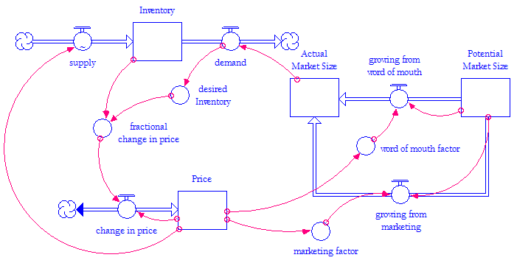

## Figure 2

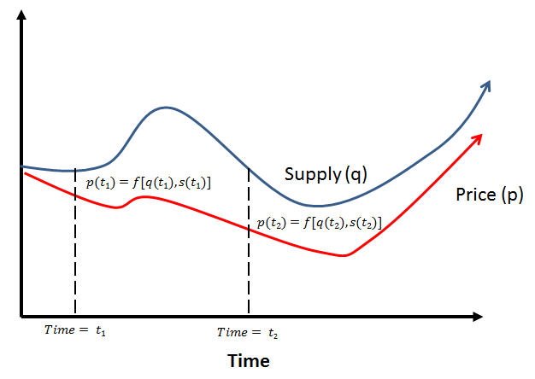

## Figure 3

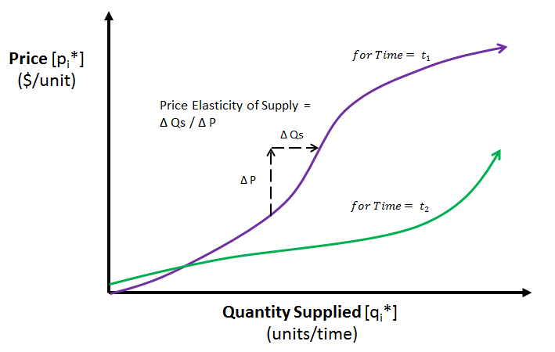

## Figure 4

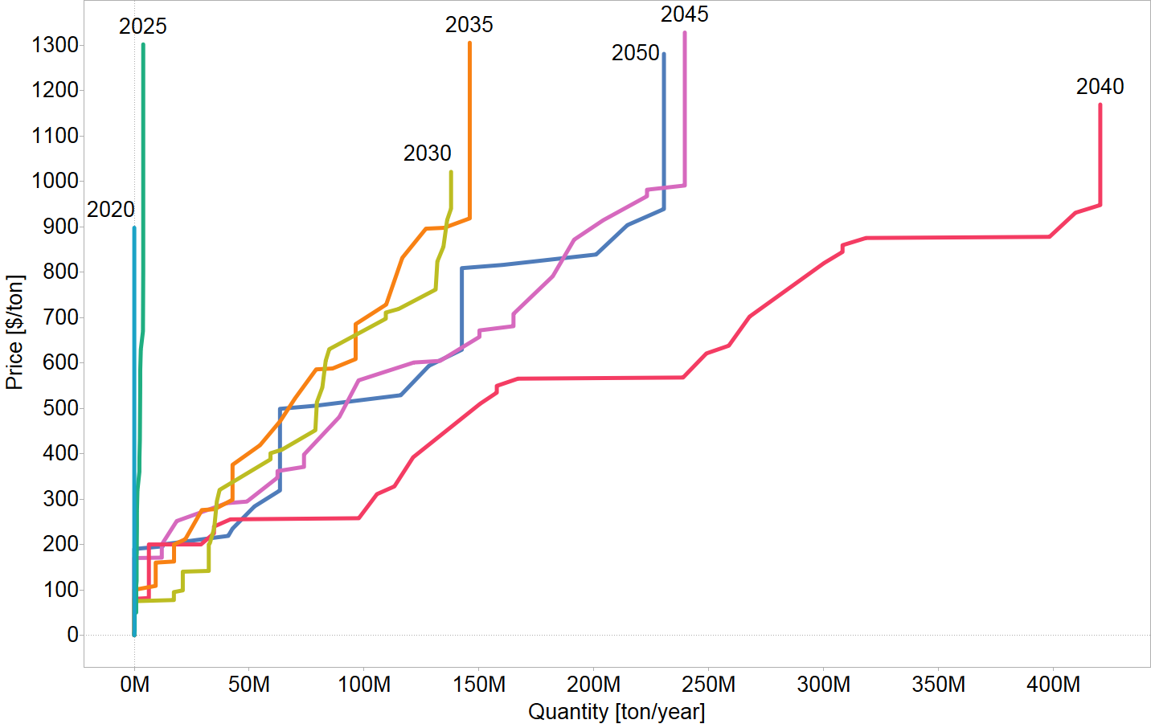

# Figure Captions

Figure 1. A simple market model demonstrates alternative approaches to generating supply (neoclassical microeconomics formulation) and demand (more traditional SD approach).

Figure 2. Generalised outputs from a hypothetical SD model illustrate the observed relationship between supply and price.

Figure 3. Derived time-dependent supply curves from a hypothetical SD model illustrate the corresponding calculation of price elasticity.

Figure 4. Supply curves at five-year intervals for woody biomass illustrate a scenario of the BSM.